INSIGHT STREAM

NAVIGATE THE NEWS LANDSCAPE

Introduction :

Project Title: Insight Stream – Navigate the News Landscape

Team ID: NM2025TMID47756

Team Leader: SHALINI N

Mail ID: shali3152008@gmail.com

Team Members:

Name: SHABIHA K

Mail ID: sshabiha446@gmail.com

Name :SHAGIN M

Mail ID : shaginmalik123@gmail.com

Name: SIVARANJINI R

Mail ID: rsivaranjini095@gmail.com

Project Overview:

Purpose:

Insight Stream is a news aggregation and analysis platform designed to users easily navigate the overwhelming digital news landscape. It collects news from trusted sources, categorizes content, provides summaries, and applies sentiment analysis to deliver insightful perspectives.

Features:

Real-time news aggregation from multiple APIs

Smart categorization (Politics, Sports, Tech, Health, etc.)

AI-driven summarization for quick reading

Sentiment analysis and trend visualization

Personalized recommendation engine

User dashboard with bookmarks and history

Architecture :

Frontend: React.js with Tailwind CSS / Material UI

Backend: Node.js + Express.js (handles API requests, news data processing)

Database: Mongo DB (stores users, preferences, bookmarks, and aggregated news)

External APIs: News API, Google News, or other RSS feeds for news sources

AI/ML: Natural Language Processing (NLP) for summarization & sentiment analysis

Setup instructions :

Prerequisites:

Node js

Mongo DB

Git

React.js

Express.js

Visual Studio Code

Installation Steps:

# Clone the repository

git clone <repo-link>

# Install client dependencies

cd client

npm install

# Install server dependencies

cd ../server

npm install

Folder structure :

INSIGHT STREAM/

├── code/

│ ├── node_modules/

│ ├── public/

│ └── src/

│ ├── components/

│ ├── context/

│ ├── pages/

│ ├── styles/

│ ├── App.css

│ ├── App.js

│ ├── App.test.js

│ ├── index.css

│ ├── index.js

│ ├── logo.svg

│ ├── reportWebVitals.js

│ └── setupTests.js

Running the Application :

Frontend:

cd click

npm start

Backend:

cd server

npm start

Access: Visit http://localhost:3000

API Documentation :

User:

POST /api/user/register

POST /api/user/login

News:

GET /api/news/latest

GET /api/news/category/:type

GET /api/news/trends

User Dashboard:

POST /api/bookmark

GET /api/bookmarks/:userId

Authentication :

JWT-based authentication for secure login

Middleware protects private routes

User Interface :

Landing Page

News Dashboard (categories, trending, sentiment)

Personalized Feed Page

Bookmark Manager

Admin Panel

Testing :

Manual Testing: During development milestones

Tools: Postman, Chrome Dev Tools, Jest (for frontend unit tests)

Screenshots or Demo :

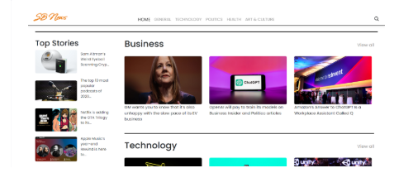

Known Issues :

Limited free-tier access to news API

Summarization accuracy may vary depending on content length

Future Enhancements :

news summarization

Voice-based search and accessibility features

Advanced AI-based bias detection in news source

Mobile app version (React Native / Flutter)

